**Creating a Network Graph from the Linear A Tablets**

Robert Hogan, Independent Researcher, robhogan@gmail.com

ABSTRACT

This paper describes the construction of an interactive online network graph (<https://lineara.xyz/network/>) based on the Linear A tablets found in Haghia Triada, Khania, Zakros and elsewhere. As a basis for the graph it proposes a classification of the tablets according to the type of transaction each tablet is interpreted as recording. This interpretation is based on the identification of a series of syntactical patterns and common structures based on these patterns that are shared by the tablets across find-places. The paper describes the syntactical patterns and gives illustrated examples of each. It finally describes the process used to construct the interactive network graph and closes with some tentative observations on the insights the graph may provide to the viewer.

INTRODUCTION

The Linear A tablets found in Haghia Triada, Khania, Zakros and elsewhere are generally considered to reflect socio-economic activity in the settlements in which they were found. Schoep (Schoep 2002). has previously proposed that the tablets represent a preliminary stage in information gathering by palace officials that ultimately resulted in economic records recorded on sealed papyrus documents. The portable form factor, and evidence of erasure and re-use, suggests that the use of the documents may have been stenographic in nature and that, rather act as a permanent record in their own right, the information contained by the tablets was later collated elsewhere.

There are many possible activities the tablets could record in an administrative context. Nearly all the tablets, regardless of find-place, are concerned with the recording of quantities of commodities. The identification of specific items such as wine, oil, grain and other products in the tablets runs along a spectrum of wide consensus to tentative speculation. What is less clear, and can generally only be reconstructed hypothetically from the internal structure of the tablets themselves, is the nature of the transactions the listed commodities were involved in. What we set out to do here is identify common patterns in the structure of the tablets and assign a hypothetical transaction type associated with each pattern, usually involving the movement of goods between two or more entities. We then use this classification to create a network graph (<https://lineara.xyz/network/>) that visualizes the movement of goods between the entities across all classifiable tablets in the Linear A corpus. We consider our attempt at classification as provisional.

## CLASSIFYING THE TABLETS

In order to construct a network map from the Linear A tablets we must first develop a basis on which to recognize transactions between entities. To do this we take an approach similar to the classifications of the tablets developed by (Palmer 1995) and (Schoep 2001) but with an emphasis on identifying entities (a person or place) as well as commodities (items or objects such as foodstuffs) in the tablets and proposing classes of transactional relationships reflected by consistent syntactical patterns in the tablets.

Our analysis identifies basic syntactical units that can be used independently but are also composable with other units to construct records of specific transaction type. We find evidence that these constructions appear across a number of tablets across a number of different find-places.

*Entity Lists and Commodity Lists*

The most basic syntactical pattern we find in the tablets is a list of entities (an ‘Entity List’) or commodities (a ‘Commodity List’). As a rule we will propose any list consisting of logograms commonly identified as commodites (such as gra, vin, nic and so on) and paired with a numeral as a ‘Commodity List’. Likewise we will propose any list consisting of sign-group followed by numeral such as in ZA 14 below as an ‘Entity List’, our assumption being that the sign-groups denote persons or places rather than objects such as commodities. Both Commodity and Entity Lists are found in all the tablets we are discussing here but there are some that consist solely of lists of entities or commodities. In most cases such ‘Entity List’ tablets record whole numbers against the entities, so for the purposes of our network map we interpret them as involving a transaction regarding the movement or allocation of people between the administrative centre and what we interpret as an entity name specified in the inscription (for example, a person or place).

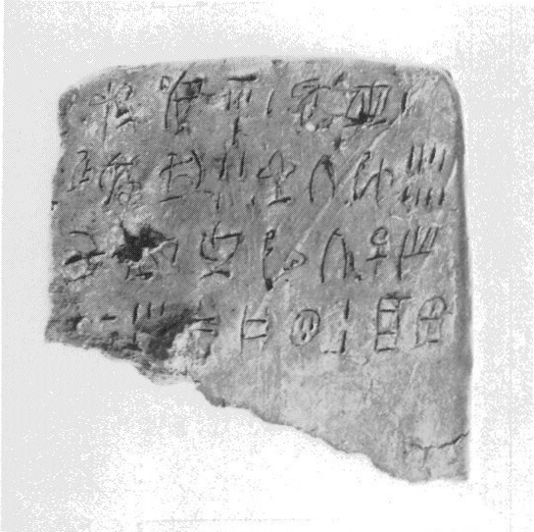Figure 1: ZA 14 Photograph (GORILA 1975)

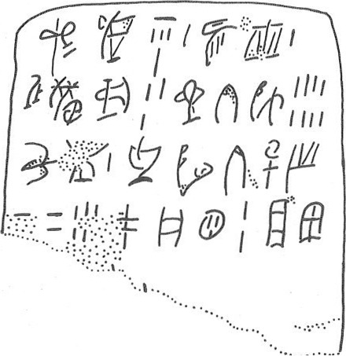Figure 2: ZA 14 Transcription (GORILA 1975)

|  |  |  |
| --- | --- | --- |
| **Tablet Reading** | | **Pattern** |
| *ME-KI-DI* | 1 | Entity List |
| *QiF-*118* | 1 |
| *PU-NI-KA-SO* | 3 |
| *QA-TI-JU* | 8 |
| *KU-PI* | 1 |
| *TU-MI-TI-ZA-SE* | 45[ |
| *PA-NU-QE* | 2 |
| *JA-WI[* | [ |

Table 1: ZA 14 – a simple entity list, possibly of people (Schoep 2002). The reading is per Younger (2023).

There are a reasonably large number of such entity lists, mostly in a fragmentary state: HT 108, HT 146, HT 25a, HT 29, HT 3, HT 39, HT 63, HT 98a, HT 99b, PE 2, ZA 10a, ZA 14, ZA 20, ZA 4a, ZA 5b, ZA 7a. There is a disproportionately high incidence of them from Zakros compared to Haghia Triada given the relative number of tablets found at each site.

It is less obvious how to treat tablet transactions that consist solely of lists of commodities (“Commodity Lists”), i.e. lists that contain only ideograms commonly recognized as denoting commodities such as grain, oil, wine, or livestock. There are however no clear examples of a tablet containing only a commodity list (instead we find the form contained within ‘Transfer Lists’ in the next section). Of the 4 we might classify as stand-alone ‘Commodity Lists’ two are in a fragmentary state (HT 24b, HT 127b) and may be related to a transaction described on the obverse of the tablet. HT 130 is largely erased and contains an isolated commodity list of cyp (grain), ni (figs), and vin (wine) at its end separated from the rest of the tablet by a dividing line. This feature listing the same commodities in the same order is also found on HT 27a and HT 89 (and possibly on the damaged HT 110a). It’s not clear what the function of this formula is in relation to the rest of the tablet each appears on but it is our only evidence of isolated commodity lists having a specific use on the Linear A tablets.

*Transfer List*

Commodity lists are by far most common, not on their own, but as part of a larger syntactical structure we term a ‘Transfer List’, an assumed movement or transaction involving commodities between two entities, one of whom is implicit (perhaps the administrative centre or magazine) and the other which is named explicitly in the list. A ‘Transfer List’ simply consists of a ‘Commodity List’ as we’ve defined it above but preceded by an Entity. There are often multiple instances of this Transfer List structure on a single tablet. A common feature of these lists is that the entity is coupled with a ‘transaction sign’ that may indicate to the scribe some additional feature of the transaction. For the purposes of constructing our network map our working hypothesis is that Transfer Lists are recording a transaction in the listed commodities between the relevant administrative centre and the entity named in the list.

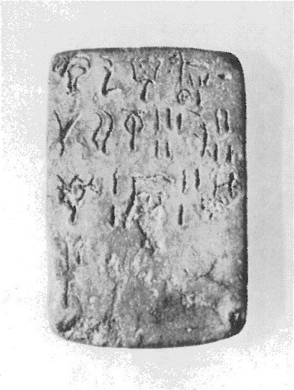Figure 3: HT121 Photograph (GORILA 1975)

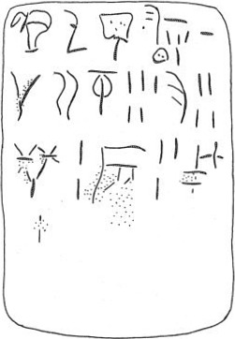Figure 4: HT121 Transcription (GORILA 1975)

|  |  |  |  |
| --- | --- | --- | --- |
| **Tablet Reading** | | **Pattern Level 1** | **Pattern Level 2** |
| *KI-RI-TA₂* |  | Entity | Transfer List |
| *OLE+QE+DI* | 10 | Commodity List |
| *SA-RA₂* |  | Entity | Transfer List |
| *GRA* | 5 | Commodity List |
| *OLE* | 4 |
| *NI* | 2 |
| *VIN* | 3 |
| *\*23M* | 3 |

Table 2: HT 121 – two transfer lists from the Haghia Triada adminstrative centre. One of a quantity of oil product to KI-RI-TA2 and another of mixed commodities to SA-RA2.

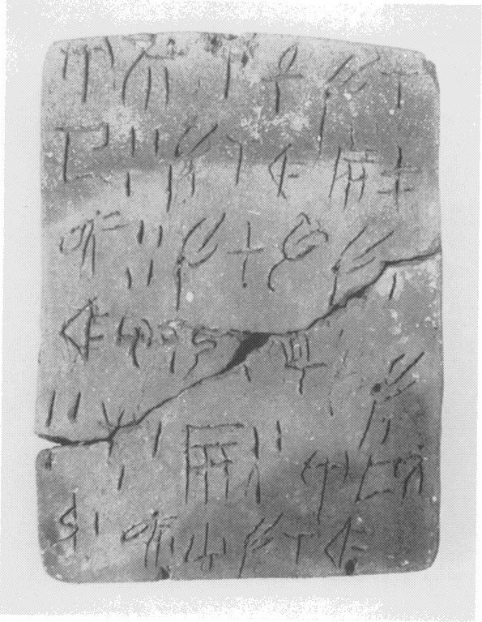Figure 5: KH 11 Photograph (GORILA 1975)

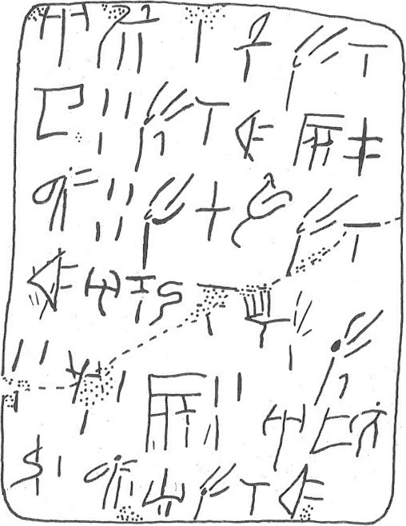Figure 6: KH 11 Transcription (GORILA 1975)

|  |  |  |  |
| --- | --- | --- | --- |
| **Tablet Reading** | | **Pattern Level 1** | **Pattern Level 2** |
| *A-DU* |  | Entity | Transfer List |
| *[ 𐄁 ]ZA* |  | Transaction Sign |
| *CYP* | K (1/10) | Commodity List |
| *SU* | 3 |
| *CYP+E* | K L2 (3/20) |
| *VIN* | A (1/24(?)) |
| *\*306* | 4 |
| *CYP* | B (1/5) |
| *\*348-CYP* | K L2(3/20) |
| *A-TO-*349-TO-I* |  | Entity | Transfer List |
| *CYP+E* | 3 | Commodity List |
| *NI* | 1 |
| *VIN* | 3 |
| *A-TA-*350* |  | Entity | Transfer List |
| *\*301* | 1 | Commodity List |
| *\*306* | 1 |
| *SI-CYP* | K L2 (3/20) |  |

Table 3: KH 11 – three transfer lists from the Khania administrative centre, each of mixed commodities to A-DU, A-TO-*349-TO-I, and A-TA-*350 respectively. Fractional values are as suggested by Corazza (2020).

A potential member of this group is KH 5, perhaps recording the same transfer to multiple entities: the same quantities of CYP+E and VINb+WI with each of *A-DA-KI-SA-KA, A-RA-U-DA,* and W*I-SA-SA-NE-E.* The rest of the tablet could then consist of two Transfer Lists, one of an unspecified quantity of *301-NA with *WI-NA-DU*, and quantities of CYP and NI to *KU-RA-ZU*.

The tablets we classify in this group are: ARKH 3a, ARKH 3b, ARKH 5, HT 100, HT 101, HT 105, HT 106, HT 108, HT 116b, HT 12, HT 121, HT 123+124a, HT 125a, HT 125b, HT 129, HT 131a, HT 131b, HT 132, HT 133, HT 14, HT 18, HT 2, HT 21, HT 23a, HT 23b, HT 24a, HT 27b, HT 30, HT 32, HT 36, HT 40, HT 42+59, HT 44a, HT 58, HT 91, HT 92, HT 94a, KH 11, KH 4, KH 7a, KH 7b, KH 9, KNZb 35, TY 3a, TY 3b, ZA 15b, ZA 1a, ZA 6a, ZA 6b, ZA 9*.*

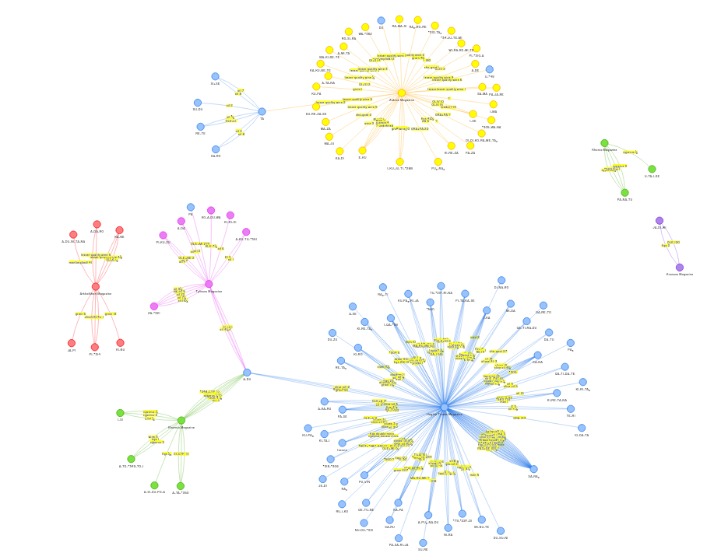Figure 7: Transfer Lists visualised. See https://lineara.xyz//network/?search=["Transfer%20List"]

*Single-Commodity Transfer List*

We find a more complex composition of a single-entry Commodity List and Entity List (together with a Named Entity and a Transaction Sign) used in a number of tablets in Haghia Triada. We propose that this structure is used to record the transfer of a single commodity to one or more entities from the administrative centre.

In HT 8a for example we read a transfer of OLE+KI from the administrative centre to seven different entities, beginning with *JE-DI.* The commodity being transferred is only named once in the tablet, so remains implicit when the amounts are recorded against the remaining entities.

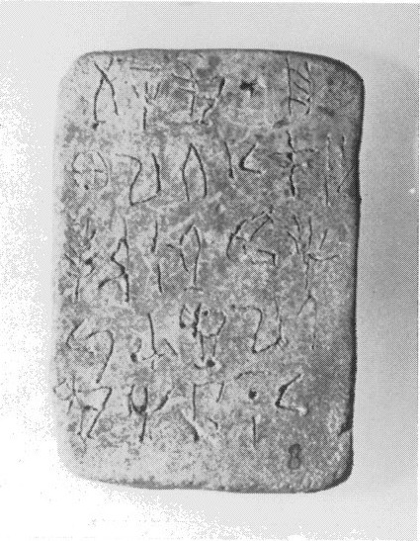Figure 8: HT 8a Photograph (GORILA 1975)

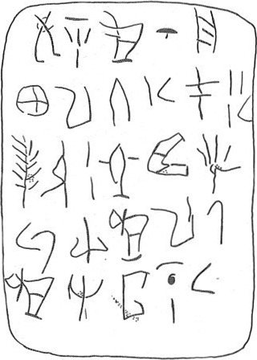Figure 9: HT 8a Transcription (GORILA 1975)

|  |  |  |  |
| --- | --- | --- | --- |
| **Tablet Reading** | | **Pattern Level 1** | **Pattern Level 2** |
| *JE-DI* |  | Entity | Single-Commodity Transfer List |
| *OLE+KI* | 10 | Commodity List |
| *PA₃-KA-RA-TI* | 1¹⁄₂ | Entity List |
| *PA* | 3 ¹⁄₂ |
| *TE-*301* | 2 |
| *QA-*310-I* | ³⁄₄ |
| *SI-KI-RA* | ¹⁄₄ |
| *KI-RE-TA-NA* | ¹⁄₂ |

Table 4: HT 8a – a transfer list of various quantities of the oil product OLE+KI between the administrative centre and seven named entities.

HT 19 has a similar structure to HT 8a, but with the addition of a ‘transaction sign’, denoting some feature of the transaction of interest to the scribe.

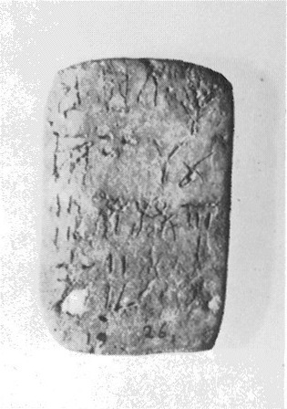Figure 10: HT 19 Photograph (GORILA 1975)

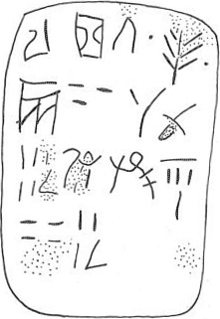Figure 11: HT 19 Transcription (GORILA 1975)

|  |  |  |  |
| --- | --- | --- | --- |
| **Tablet Reading** | | **Pattern Level 1** | **Pattern Level 2** |
| *RA-*164-TI* |  | Entity | Single-Commodity Transfer List |
| *𐄁 TE𐄁* |  | Transaction Sign |
| *VIN* | 30 | Commodity List |
| *SA-RO* | 5¹⁄₂ | Entity List |
| *DU-ME-DI* | 43¹⁄₂ |

Table 5: HT 19 – a transfer list of wine (VIN) between the administrative centre and the three named entities: RA-*164-TI, SA-RO, and DU-ME-DI.

The tablets we classify in this group are: HT 103, HT 110a, HT 17, HT 19, HT 89, HT 8a, HT 97a, KH 88.

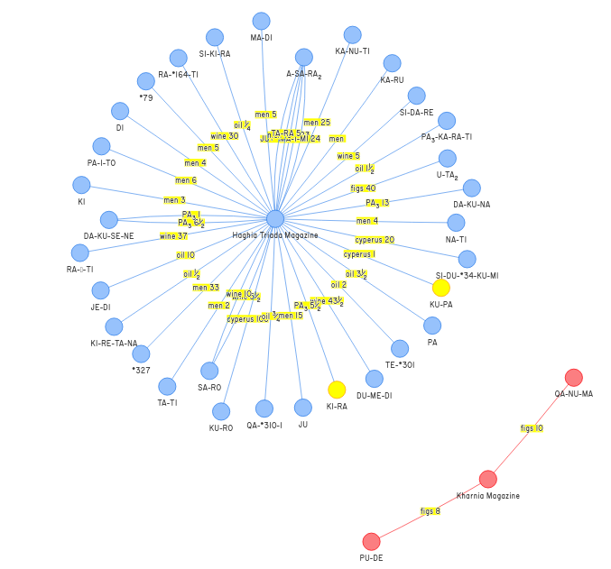

Figure 12: Single commodity transfer lists visualized. See https://lineara.xyz//network/?search=["Single-Commodity%20Transfer%20List"]

*Multiple-Commodity Inter-Entity Transfer List*

This structure builds on the ‘Transfer List’ by pre-pending an additional entity to the ‘Transfer List’ structure. We assume that in this case the tablet is recording a transaction between two third parties rather than a transfer of the same amount of goods between the administrative centre and two distinct entities. Our basis for this preference is subjective: it will allow the graph we construct to explore the potential for relationships between entities rather than just with the adminstrative centre. As with the Transfer List this pattern can also accommodate the use of transaction signs in its heading.

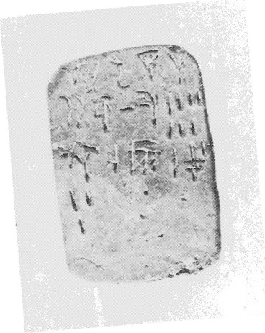Figure 13: HT 114a Photograph (GORILA 1975)

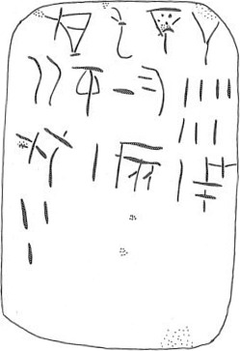Figure 14: HT 114a Transcription (GORILA 1975)

|  |  |  |  |  |  |
| --- | --- | --- | --- | --- | --- |
| **Tablet Reading** | | **Pattern Level 1** | **Pattern Level 2** | **Pattern Level 3** | |
| *KI-RI-TA₂* |  | Entity | Entity | | Multiple-Commodity Inter-Entity Transfer List |
| *SA-RA₂* |  | Entity | Transfer List | |
| *GRA* | 10 | Commodity List |
| *OLE* | 7 |
| *NI* | 1 |
| *VIN* | 1 |
| *\*23M* | 3 |

Table 6: HT 114a – a transfer list of multiple commodities between KI-RI-TA2 and SA-RA2.

The tablets we classify in this group are: HT 114a, HT 116a, HT 11b, HT 120, HT 125b, HT 128a, HT 16, HT 20, HT 28a, HT 28b, HT 31, HT 33, HT 34, HT 35, HT 43, HT 90, HT 91, HT 96b, HT 99a, KH 7a, PE 1, ZA 11a, ZA 11b.

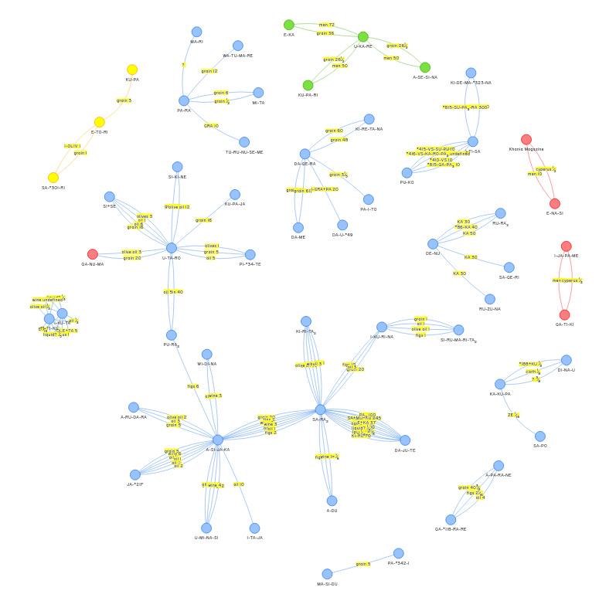

Figure 15: https://lineara.xyz/network/?search=["Multiple-Commodity%20Inter-Entity%20Transfer%20List"]

*Single-Commodity Inter-Entity Transfer List*

This is a syntactical pattern built on the ‘Entity List’ pattern rather than the ‘Commodity List’. It displays the same basic combinatorial pattern as the ‘Transfer List’ of a named entity, but with an ‘Entity List’ instead of a ‘Commodity List’. As with the other structures we have so far encountered it accommodates the use of a transaction sign in the headwords. For the purposes of our network map we propose that this type of list is recording a movement of some sort between the entity named in the head words and the entities named in the list. In a common form of the pattern there is no indication of the commodity that is being transferred between the entities.

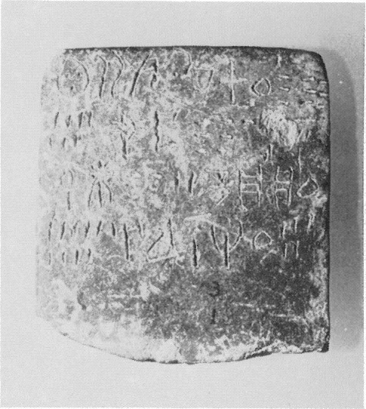Figure 16: HT 1 Photograph (GORILA 1975)

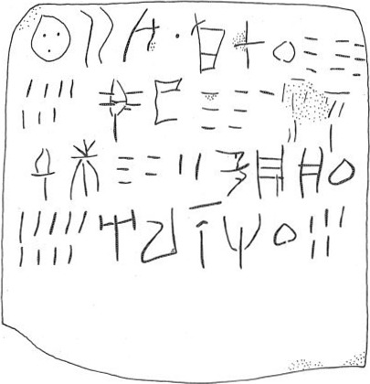Figure 17: HT 1 Transcription (GORILA 1975)

|  |  |  |  |  |
| --- | --- | --- | --- | --- |
| **Tablet Reading** | | **Pattern Level 1** | **Pattern Level 2** | |
| *QE-RA₂-U 𐄁* |  | Entity | | Single-Commodity Inter-Entity Transfer  List |
| *KI-RO* | 197 | Entity List | |
| *ZU-SU* | 70 |
| *DI-DI-ZA-KE* | 52 |
| *KU-PA₃-NU* | 109 |
| *A-RA-NA-RE* | 105 |

Table 7: HT 1 – a transfer of an unspecified commodity between QE-RA2-U and 5 named entities.

The tablets we classify in this group are: HT 1, HT 104, HT 10a, HT 10b, HT 117a, HT 122a, HT 123+124b, HT 126a, HT 15, HT 20, HT 26a, HT 85b, HT 88, HT 94b, HT 95b, HT 9b.

There is a distinct variation in the pattern that accommodates a commodity in the head words. In such cases we hypothesize that the tablet is recording the movement of this named commodity.

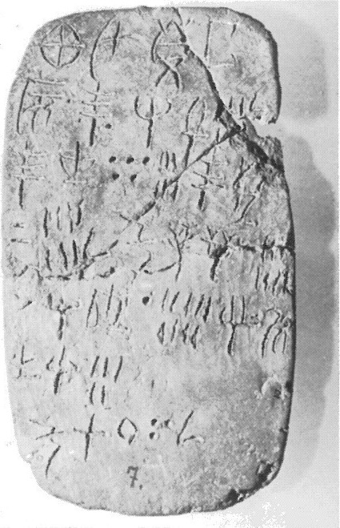Figure 18: HT 13 Photograph (GORILA 1975)

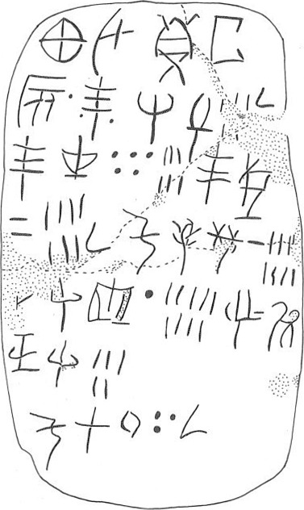Figure 19: HT 13 Transcription (GORILA 1975)

|  |  |  |  |  |
| --- | --- | --- | --- | --- |
| **Tablet Reading** | | **Pattern Level 1** | **Pattern Level 2** | |
| *KA-U-DE-TA* |  | Entity | | Single-Commodity Inter-Entity Transfer  List |
| *VIN* |  | Commodity | |
| *𐄁 TE 𐄁* |  | Transaction Sign | |
| *RE-ZA* | 5[ ]¹⁄₂[ | Entity List | |
| *TE-TU* | 56 |
| *TE-KI* | 27 ¹⁄₂ |
| *KU-ZU-NI* | 18 |
| *DA-SI-*118* | 19 |
| *I-DU-NE-SI* | 5 |
| *KU-RO* | 130 ¹⁄₂ |

Table 8: HT 13 – a transfer of wine between KA-U-DE-TA and 6 named entities. KU-RO is assumed to represent a total.

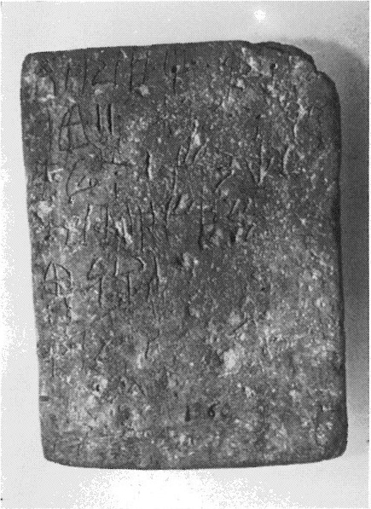Figure 20: HT 115a Photograph (GORILA 1975)

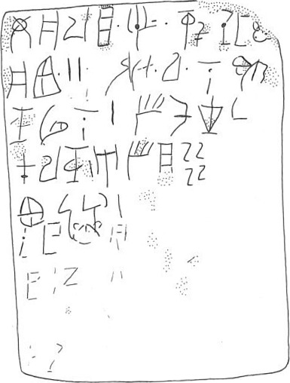Figure 21: HT 115a Transcription (GORILA 1975)

|  |  |  |  |  |
| --- | --- | --- | --- | --- |
| **Tablet Reading** | | **Pattern Level 1** | **Pattern Level 2** | |
| *\*47-NU-RA-JA* |  | Entity | | Single-Commodity Inter-Entity Transfer  List |
| *𐄁I𐄁* |  | Transaction Sign | |
| *GRA+BOSm* |  | Commodity | |
| *RI-TA-MA-NU-WI* | 2 | Entity List | |
| *\*301-U-RA* |  | Entity | | Single-Commodity Inter-Entity Transfer  List |
| *NA-*21F-NE-MI-NA* | 1 | Entity List | |
| *SE-KU-TU* | ¹⁄₂ |
| *PA-RA-NE* | 1 |
| *A-SE-JA* | 2/3 |
| *KA-PO-RU* | 1 |
| *RI-SU-MA[* | [ ] |
| *SU* | 2 1/6[ |

Table 9: HT 115a – two transfers of quantities of GRA+BOSm. The first between *47-NU-RA-JA and RI-TA-MA-NU-WI. The second between *301-U-RA and 7 named entities. The fractions given are as suggested by Corazza (2020).

The tablets we classify in this group are*:* ARKH 2, HT 102, HT 115a, HT 115b, HT 122b, HT 13, HT 26a, HT 6a, HT 6b, HT 7a, HT 7b, HT 85a, HT 86a, HT 86b, HT 95a, HT 9a, ZA 10b, ZA 15a, ZA 5a, ZA 8.

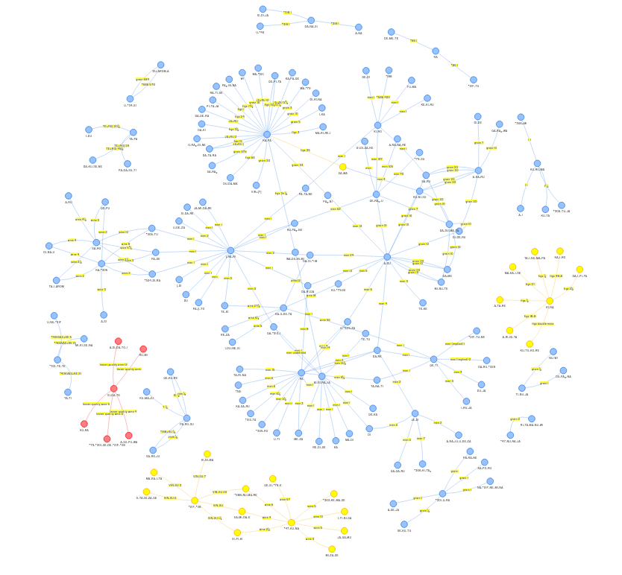

Figure 22: <https://lineara.xyz/network/?search>=["Single Unnamed Commodity Inter-Entity Transfer List","Single Named Commodity Inter-Entity Transfer List"]

*Complex Structures*

Tablets in this group display sufficient complexity to resist easy classification under any of our previous headings. This may be due to a difference in concerns from already classified tablets and for that reason we will treat each of them individually here.

HT 87 and HT 117a may list people by name and not reflect any transaction function (Younger 2023). In both cases the tablet contain Entity Lists with whole numbers assigned, preceded by multiple head words.

HT 88 contains a Single-Commodity Transfer list, a Commodity combined with an Entity List, and a Single-Commodity Inter-Entity Transfer List.

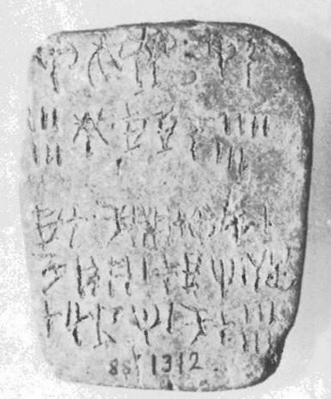Figure 23: HT 88 Photograph (GORILA 1975)

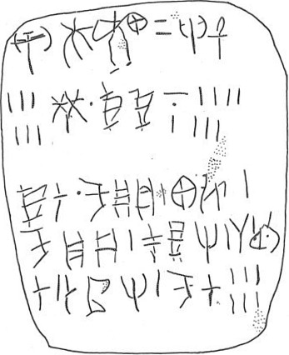Figure 24: HT 88 Transcription (GORILA 1975)

|  |  |  |  |  |
| --- | --- | --- | --- | --- |
| **Tablet Reading** | | **Pattern Level 1** | **Pattern Level 2** | |
| A-DU |  | Entity | | Single-Commodity Transfer list |
| VIR+KA | 20 | Commodity List | |
| RE-ZA | 6 | Entity List | |
| NI 𐄁 |  | Commodity | | Transfer List (?) |
| KI-KI-NA | 7 | Entity List | |
| KI-RO 𐄁 |  | Entity | | Single-Commodity Inter-Entity Transfer List |
| KU-PA₃-PA₃ | 1 | Entity List | |
| KA-JU | 1 |  | |
| KU-PA₃-NU | 1 |  | |
| PA-JA-RE | 1 |  | |
| SA-MA-RO | 1 |  | |
| DA-TA-RE | 1 |  | |
| KU-RO | 6 |  | |

Table 10: HT88

We see a similar structure to ‘*NI𐄁 KI-KI-NA* 7’ in HT 15: ‘*188𐄁 *KI-RO* 400’. Since it is not common it may be a variation on the ‘Transfer List’, e.g. ‘*KI-KI-NA𐄁 NI* 7’. Also in HT 103.

HT 96a contains 4 head words. If the first three are to be considered separately then the text from *SI-MI-TA* to the dividing line may be read as a Single Commodity Transfer List.

TY 2 may be a list of commodities or entities (commodities seems more likely). If the entries beginning with *309 are indeed commodities then the tablet consists of a Commodity List followed by a Transfer List (with *PA-DA-RU*).[1]

## CONSTRUCTING A NETWORK GRAPH

In order to create a network graph that visualizes the transactions between proposed entities we chose a third-party javascript library called ‘*vis-network*’ (Vis 2023). This is a module of computer code written in the Javascript programming language that can be embedded in a website and used by the website to display an interactive network graph in the user’s web browser. In order to achieve this, *vis-network* requires us to build a database of nodes (entities) with transactions as the edges between the nodes. The most convenient way of doing this is to construct a simple text file for each tablet with the content formatted in such a way that it identifies the proposed nodes in the graph and includes metadata identifying the commodities and values for each transaction between the nodes.[2] An example of what this looks like for the pair of relatively simple ‘Transfer Lists’ given in HT 121 is as follows:

{

    "name": "HT121",

    "transactions": [

        {

            "description": "sender",

            "transactionID": "HT121-1",

            "transliteratedWord": "Haghia Triada Magazine"

        },

        {

            "description": "sender",

            "transactionID": "HT121-2",

            "transliteratedWord": "Haghia Triada Magazine"

        }

    ],

    "words": [

        {

            "description": "recipient",

            "transactionID": "HT121-1",

            "transliteratedWord": "KI-RI-TA₂",

            "word": "𐘸𐘭𐘷"

        },

        {

            "commodityID": 1,

            "description": "commodity",

            "transactionID": "HT121-1",

            "transliteratedWord": "OLE+QE+DI",

            "word": "𐜘"

        },

        {

            "commodityID": 1,

            "description": "quantity",

            "transactionID": "HT121-1",

            "transliteratedWord": "10",

            "word": "𐄐"

        },

        {

            "description": "recipient",

            "transactionID": "HT121-2",

            "transliteratedWord": "SA-RA₂",

            "word": "𐘞𐘽"

        },

        {

            "commodityID": 1,

            "description": "commodity",

            "transactionID": "HT121-2",

            "transliteratedWord": "GRA",

            "word": "𐙉"

        },

        {

            "commodityID": 1,

            "description": "quantity",

            "transactionID": "HT121-2",

            "transliteratedWord": "5",

            "word": "𐄋"

        },

        {

            "commodityID": 2,

            "description": "commodity",

            "transactionID": "HT121-2",

            "transliteratedWord": "OLE",

            "word": "𐙖"

        },

        {

            "commodityID": 2,

            "description": "quantity",

            "transactionID": "HT121-2",

            "transliteratedWord": "4",

            "word": "𐄊"

        },

        {

            "commodityID": 3,

            "description": "commodity",

            "transactionID": "HT121-2",

            "transliteratedWord": "NI",

            "word": "𐘝"

        },

        {

            "commodityID": 3,

            "description": "quantity",

            "transactionID": "HT121-2",

            "transliteratedWord": "2",

            "word": "𐄈"

        },

        {

            "commodityID": 4,

            "description": "commodity",

            "transactionID": "HT121-2",

            "transliteratedWord": "VIN",

            "word": "𐙍"

        },

        {

            "commodityID": 4,

            "description": "quantity",

            "transactionID": "HT121-2",

            "transliteratedWord": "3",

            "word": "𐄉"

        },

        {

            "commodityID": 5,

            "description": "commodity",

            "transactionID": "HT121-2",

            "transliteratedWord": "*23M",

            "word": "𐘖"

        },

        {

            "commodityID": 5,

            "description": "quantity",

            "transactionID": "HT121-2",

            "transliteratedWord": "3",

            "word": "𐄉"

        }

    ]

}

For each transaction we designate ‘sender’ and ‘recipient’ nodes - these are convenience terms only since we are not presenting a directed graph and do not have a strong hypothesis on which direction the commodities are flowing in any given ‘Transfer List’. For each commodity and value that we propose is passing between the nodes we assign a unique transactionID. Each combination of commodityID and transactionID will constitute a unique edge between the two nodes associated with that transaction. In the above example there are 5 edges between the administrative centre (the ‘Haghia Triada Magazine’) and *SA-RA₂.* As we construct our graph in this way, the assumptions underlying our analysis of the tablets becomes strongly apparent. We assume the tablets included in the analyst contain a record of goods transfers between entities rather than a record of goods stored (for example). We may contend that this view is supported by the relative absence of simple ‘Commodity Lists’ we noted when seeking examples of ‘Commodity Lists’ independent of other syntactic structures in the tablets, but ultimately it is an assumption guided by our objective to build a graph of potential relationships between entities.

Fortunately it was not necessary to construct the entries for every tablet by hand. We wrote a computer program in the Python programming language that made an informed guess for the appropriate construction of the text file for each tablet, based on our proposed classification.[3] Each entry was then reviewed and corrected as required, before being merged into a single file, transactions.js.[4]

When a user loads <https://lineara.xyz/network> the page constructs a full list of all nodes given in transactions.js and builds a network of edges that connect them. In order to help the user distinguish between the different geographies associated with the tablets, nodes for each find-place are assigned a unique color. We also annotate each edge with its commodity and value.

To assist the user in exploring the graph we have made the nodes interactive. Clicking on a node will limit the displayed graph to just that node and other nodes connected to it. The user can in this way build up a graph of just the nodes and edges they are interested in.

The graph also has a search function. Searching can be done on tablet name, entity name, find-place. Search terms are cumulative, again allowing the user to build up a cumulative picture of just the nodes that interest them.

We consider our interpretation of the tablets provisional, so it is important to allow the critical user view the source of any given relationship represented in the graph. For this reason, when a user hovers overs an edge in the graph we display the tablet the nodes and edge are sourced from with the relevant words in the tablet highlighted. This permits the user easily to assess if the relationship is a valid one according to their own interpretation of the tablet.

## OBSERVATIONS ON THE NETWORK GRAPH

As might be expected our graph is dominated by nodes from Haghia Triada (HT). Most prominent are transfers between the HT administrative centre (designated the ‘Haghia Triada Magazine’ in the graph) and other entities.

But we also observe a large tangle of connections (‘network edges’) between Haghia Triada nodes that do not involve the administrative centre. This is based largely on those tablets we’ve classified as ‘Inter-Entity Transfer Lists’ in our analysis. If our interpretation of the tablets is correct, and that is a very tentative ‘if’, this would indicate a high degree of economic activity between entities around the Haghia Triada centre. Some nodes are much more connected than others: *SA-RA2, KA-RA, A-SI-JA-KA, A-DU* are highly connected for example. This may indicate that these are entities more economically active than the others found in the tablets, but it may also suggest that they are not entities but words with a specific adminstrative meaning or function, such as transaction vocabulary. A-DU, for example, has been proposed as a word meaning ‘assessment’. Such considerations aside, what is striking from this part of the graph is how many HT nodes have more than one edge, in other words they are involved in more than one transaction with other nodes in the network.

But the purpose of this graph is not for me to make inferences about Minoan economic activity but to allow the reader to explore it for themselves and decide if it provides any useful insights. The basis for constructing the graph is inescapably provisional; the classification and interpretation of Linear A tablets is always a castle built on sand, and the system I’ve suggested here unquestionably has the limitation of assuming that the majority reflect relatively straightforward transactions. For this reason, the network graph is offered as a visualisation tool for the interested reader to aid the ongoing inquiry in Linear A studies, championed in particular by Younger and Schoep, into what the purpose of each tablet may have been rather than what the individual words on the tablet may have signified.

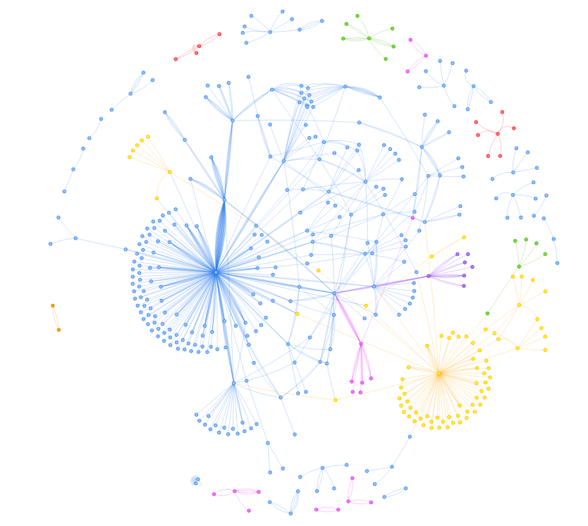

Figure 25: A view of the complete network graph. The user can use the mouse wheel to zoom in and out of the graph. Haghia Triada is in blue, Zakros in yellow, Kharnia in pink, Tylissos in purple, Arkhanes in green, Petras in red.

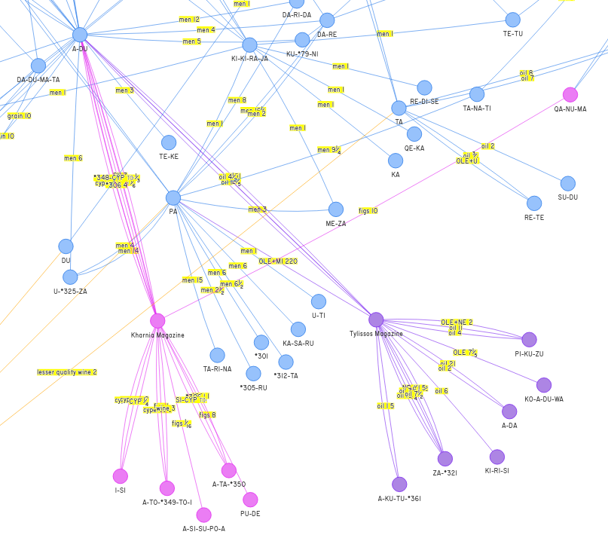

Figure 26: A detail from the graph showing the nodes that connect Haghia Triada with Tylissos and Kharnia.

### BIBLOGRAPHY

Corazza 2020. Corazza M., Ferrara S., Montecchi B., Tamburini F., and Valério M. 2020, The mathematical values of fraction signs in the Linear A script: A computational, statistical and typological approach, Journal of Archaeological Science 125, 105–214

GORILA, Louis Godart and Jean-Pierre Olivier, Recueil des inscriptions en Linéaire A. Études Crétoises 21, vols. 1-5. (Paris: Librairie Orientaliste Paul Geuthner, 1976-1985

Palmer 1995, R.Palmer, “Linear A Commodities: a Comparison of Resources”, Aegeum 12 (1995), p.133-155.

Schoep 2000, Schoep Ilse, The Administration of Neopalatial Crete: A Critical Assessment of the Linear A Tablets and Their Role in the Administrative Process (Salamanca: Ediciones Universidad Salamanca).

Schoep 2001, Schoep Ilse. The role of the Linear A tablets in Minoan administration. In: Ktèma : civilisations de l'Orient, de la Grèce et de Rome antiques, N°26, 2001. pp. 55-62;

Younger 2023, John G. Younger, Published Online (<https://www.people.ku.edu/~jyounger/LinearA/misctexts.html>, [https://people.ku.edu/~jyounger/LinearA/#11](https://people.ku.edu/~jyounger/LinearA/" \l "11), ), 2023

Vis 2023, https://github.com/visjs/vis-network

1. The following tablets are too fragmentary to permit classification: ARKH 4b, HT 110b, HT 137, HT 139, HT 140, HT 154a, HT 25b, HT 26b, HT 27a, HT 3, HT 38, HT 45b, HT 49a, HT 50a, HT 51a, HT 60, HT 62+73, HT 69, HT 82, HTZd 157+156, KH 12, KH 15, KH 21, KH 25, KH 26, KH 54, KH 55, KH 58, KH 6, KH 60, KH 61, KH 63, KH 73, KH 75, KH 76, KH 8, KH 84, KH 91, KN 2, KN 28a, MA 4a, MA 6a, MA 6c, PH 3b, PH 8a, PK 3, THEZb 5, THEtab.4, ZA 12a, ZA 12b, ZA 18a, ZA 1b, ZA 26a, ZA 4b.
2. https://github.com/mwenge/lineara.xyz/tree/master/network/transactions/final
3. https://github.com/mwenge/lineara.xyz/blob/master/network/transactions/030%20-%20Create%20Transactions.ipynb
4. https://github.com/mwenge/lineara.xyz/blob/master/network/transactions.js